City of Tempe  Community Development  Building Safety  PO Box 5002  Tempe, AZ 85280  480-350-4311  www.tempe.gov | ADDRESSING  POLICY | 

PURPOSE

The development of the City of Tempe makes it essential that uniform and consistent addressing practices be updated and implemented. To meet this objective, addressing procedures are hereby established for the following purposes:

- To clearly identify a North-South, East-West point of reference for a property numbering system.

- To establish and regulate a uniform and consistent property numbering system to enable emergency response personnel, as well as the public, to readily locate property addresses.

- To assist the postal service with the efficient delivery of mail by regulating the proper use of addresses.

- ADMINISTRATION

The Community Development Department is responsible for the assignment of addresses, suite and/or unit numbers and building identification letters. New developments shall be initially processed under the address and/or parcel number assigned for each undeveloped parcel. The Building Safety Division shall subsequently assign the final address or addresses while the project plans are under review and before building permits are issued with each building being suited at time of permit review of a shell building.

In addition, the Building Safety Division is responsible for the assignment of the individual suite and/or unit numbers.

An application shall be required for the assignment of new addresses, re-addressing of a site, or re- suiting of a project.

Once assigned, all building addresses and suite and/or unit numbers shall:

➢ Be forwarded by the Community Development Department to the U.S. Postal Service, Tempe Police Department, Tempe Fire Medical Rescue Department, Maricopa County Assessor’s Office, and all utility companies at the first of every month.

➢ Be maintained and compiled in a complete inventory of existing site addresses. Any changes occurring shall be entered into the ARCGIS Mapping System.

➢ Be verified for plan submittals for all applications to the Community Development Department.

➢ Any development, properties, or sites with perimeter walls shall have the address number visible on the outside of the wall for public access.

➢ One (1) and two (2) family dwellings shall provide four (4) inch address numbers on the front elevation and on the rear elevations when abutting an alley.

➢ Addresses shall be at least four (4) inches in height and have a color contrast with the background color of at least fifty percent (50%).

➢ Shall be self-illuminated or located eighteen (18) to thirty-six (36) inches below a light fixture.

➢ All numbers and letters shall be illuminated from dusk to dawn, except for one (1) or two (2) family dwellings, rear addresses, alley gates, curbside mailboxes.

- ADDRESSING

- REFERENCE BASELINES

- The north-south reference baseline for the City of Tempe is the centerline of the Salt River at Mill Avenue.

- The north-south baselines for the City of Tempe shall be known as follows, and assigned the block numbers as indicated.

a. 48th Street 2800 W
b. Priest Drive 1400 W
c. Hardy Drive 1000 W
d. Kyrene Road (North) 300 W
e. Kyrene Road (South) 500 W
f. Mill Avenue 0
g. Rural Road 900 E
h. McClintock Dr. 1800 E
i. Price Road 2200

- The east-west reference baseline for the City of Tempe shall be known as Mill Avenue

- The east-west baselines for the City of Tempe shall be known as follows and assigned the block numbers as indicated.

a. Continental Drive 2800 N
b. McKellips Road 2000 N
c. Curry Road 1000 N
d. Center of Salt River 0
e. Rio Salado Parkway 100 S
f. University Drive 800 S
g. Apache Boulevard 1300 S
h. Broadway Road 2000 S
i. Southern Avenue 3300 S
j. Baseline Road 5200 S
k. Guadalupe Road 6400 S
l. Elliot Road 7600 S
m. Warner Road 8800 S
n. Ray Road 10000 S

- ASSIGNMENT OF NUMBERS TO INDIVIDUAL PROPERTIES.

- Sequential whole numbers shall be assigned at a minimum of one number for each 20' of frontage along the street and in conjunction with the grid system for the City of Tempe with Mill Avenue as the zero east-west reference point and the middle of the Salt River as the zero north-south reference point.

- Even numbers shall be assigned to the north and west side of the street and odd numbers shall be assigned to the south and east sides.

- All buildings on diagonal streets shall be numbered the same as buildings on northerly and southerly streets if the diagonal runs more from the north to the south, and the same rule shall apply on easterly and westerly streets if the diagonal runs more from the east to the west. The numbers assigned shall be measured as true north-south and east-west distances from the dedicated reference streets to which the diagonal street intersects and not along the diagonal.
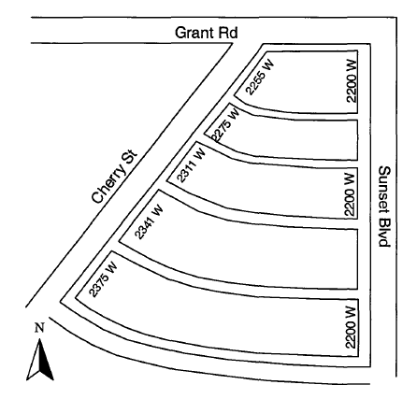

- Buildings fronting on private streets shall be assigned addresses according to the numbering grid as if they were public, whether dedicated or not.

- The site address assigned to a lot or parcel shall be off the street that the lot or parcel has access to (where the driveway is located).

- Corner lots shall be assigned an address on the narrower frontage but may be changed depending on site, driveway, and entrance location of buildings.

- Site addresses shall be assigned to subdivisions upon submittal to Planning and Zoning of the final plat.

- A processing site address shall be assigned to a multi-family, commercial or industrial development when a site plan has been submitted to the Planning and Zoning Division of the Community Development Department.

- Site addresses for temporary power and/or utilities may be assigned on a case by case basis.

- Site addresses for streetlights shall be assigned by the Community Development Department and shall be given the closest existing address or in case of location on a property line, the lower of the two existing site addresses. A pole identification code or number may be assigned but is not considered part of the site address.

- Site addresses for traffic signals, controllers and railroad signals shall be assigned as requested by the Traffic Department.

- Site addresses assigned to water/electric meters and sprinkler control boxes shall have a site/vicinity plan or plat submitted so that the proper grid location may be determined.

- SPECIAL CIRCUMSTANCES

1. Circles

Address numbers shall be assigned in a regular manner to the side of the street having the greatest property frontage along the street, using consecutive odd or even numbering. Numbers shall then be assigned to the side having the shorter frontage so that these numbers correspond with the properties on the opposite side of the street. Even numbers shall be assigned on the outside of the circle, and odd numbers shall be assigned on the inside of the circle.

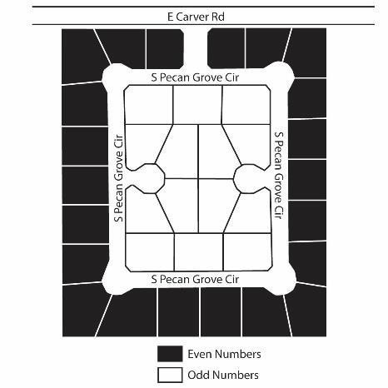
2. Loops

When a looped street is split in two halves as distinguished by a street name change of any sort (including a simple directional prefix of suffix change), the two halves are assigned address numbers separately. Numbering is based on the predominant direction of that portion of the looped street.
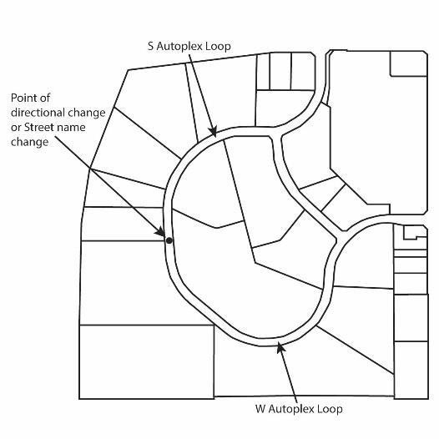

- Courts

Address assignment for courts shall use frontage numbers that are even on one side to a point approximately halfway to the top of the turnaround and then switch to odd numbers back along the opposite side of the court. Even/odd numbering shall reflect normal orientation to the address system point of origin.
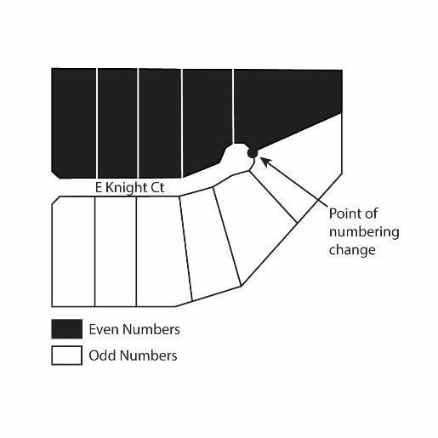
- Cul De Sacs

If the cul-de-sac street name is the same as the street from which it projects, the address numbering shall be assigned as though the lots were in sequence on the street while taking care not to exceed the corresponding grid on the opposite side. If the cul-de-sac street name is different than the street from which it projects, the numbering shall be the same as a court for addressing purposes.

- Horseshoe Streets

Horseshoe shaped streets with two names shall change even-odd system at the point of the most distinct bend and the names start and end at this point.
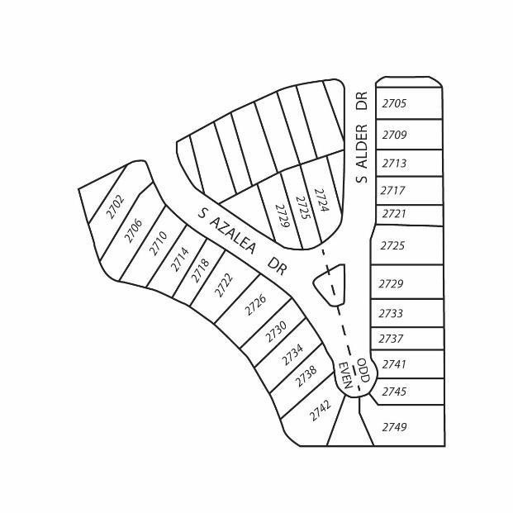

- SPECIAL USES

- Townhouses

An individual site address shall be assigned to each townhouse when available.

- Duplexes

Whole numbers shall be used. Fractions of numbers, letters, or "front" or "rear" shall NOT
be used. Each residential unit shall be assigned an individual address, when available.

- Accessory Dwelling Units (ADU’s)

No separate address shall be issued for an accessory dwelling, instead the unit shall be addressed with the letter “A” following the address of the principle dwelling. i.e., 1234 - A

The address shall be visible from the point of entry for the ADU.

No more than one (1) attached and one (1) detached ADU is allowed on any lot that is less than one (1) acre per Section 3-402 of the Zoning and Development Code.

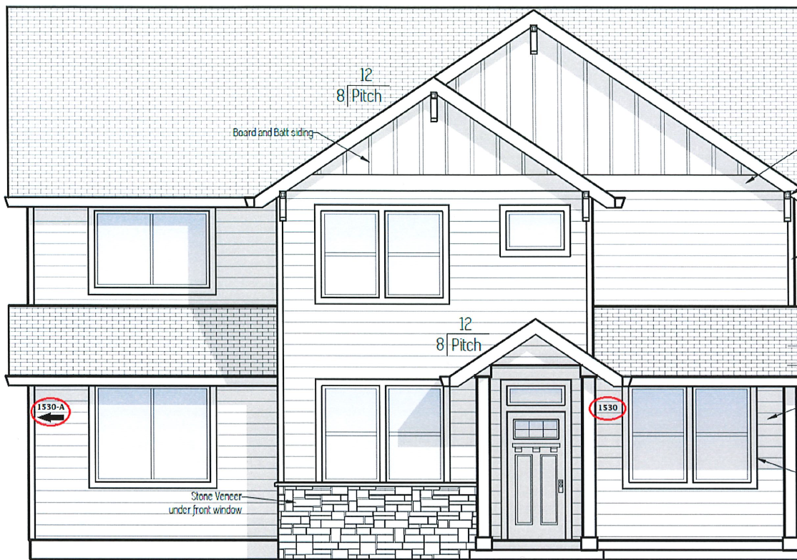

- Apartments/Condominiums

A master address shall be assigned for each complex based on the dedicated thoroughfare where the main entrance is located. An identifying letter (not part of the mailing address) shall be assigned to each building (A, B, C…. etc.) and consecutive unit numbers assigned in the same progression.

Regardless of the number of assigned site addresses, unit numbering shall remain consecutive throughout the entire development to avoid duplication of numbers

- Unit numbers shall be assigned in a clockwise direction, beginning to the left of the main addressed entrance as follows:

Single Story to Nine Story Buildings:

a. First floor: 1001-1999
b. Second floor: 2001-2999
c. Third–Ninth floor: 3001-9999

Ten Story and Above Buildings:

a. First floor: 101-199
b. Second floor: 201-299
c. Third-Ninth floor: 301-999
d. Tenth floor & above: 1001-X9999

- The provisions of this section shall serve as the regulations for the assignment of unit numbers on all multi-occupancy buildings within the City of Tempe.

- The purpose of this section is to establish a consistent method for the assignment of unit numbers. These requirements are intended to aid fire fighters and other emergency responders, provide for efficient access to property records and information, ensure conformance to the standards of the U. S. Postal Service and utility companies.

- The actual size, color, and field placement of unit numbers shall be as specified in the Zoning and Development Code of the City of Tempe.

- Mobile home parks, mobile home subdivisions and trailer parks

- Mobile homes and trailer parks

The property of a mobile home and/or trailer park shall be assigned one site address on the dedicated street on which the main entrance fronts. Each lot shall have a designated space number assigned and approved that shall appear on the recorded plat.

- Mobile home subdivision

If the development is a mobile home subdivision following normal subdivision regulations, the properties shall be addressed as individual residences.

- Commercial/Office/Industrial

- Sites with Multiple Commercial/Office/Industrial Structures

A separate frontage number shall be assigned to each structure, if possible, based on the building orientation and site access. On a case by case basis, major tenants within a single structure may receive a separate frontage number. Each structure shall be assigned suite numbers on at least one suite number per every twenty (20) feet of frontal space. The suiting of such structures shall be done at time of review of the shell building and before issuance of the building permit.

If a single frontage number is not available for each structure, a single frontage number shall be used for the whole development. An identifying letter which is not part of the mailing address shall be assigned to each building within the project. All structures within a single site address shall be assigned suite numbers consecutively to avoid the duplication of numbers.

- Sites with Single Commercial/Office/Industrial Structure

Each structure shall be assigned a site address on the dedicated street on which the building front faces. Suite assignments shall be assigned on a maximum of one suite number per twenty (20) feet of office or unit frontage. Structures used as warehouses, manufacturing, single use, general office complex, (etc.) shall be suited at time of review of the shell building and before issuance of the building permit.

- Suite number assignment

- All spaces within multi-occupant buildings shall be assigned individual suite numbers. Separate street addresses shall not be assigned to multiple tenants in a single building.

- The Building Safety Division shall initiate this process once the project has received final approval from the Planning and Zoning Division of Community Development.

- The actual size, color, and field placement of suite and unit numbers shall be as specified in the Zoning and Development Code of the City of Tempe

- The project applicant must submit a separate site plan including the building layouts (preferably in PDF format) to the Building Safety Division for suite and/or unit number assignment. This submittal shall consist of a properly scaled site plan depicting the orientation of the site, building floor plans, parking lots, driveway locations, building exits, elevators, lobbies, and corridors. Proposed tenant layout plans may also be submitted with the required site plan to assist in the proper assignment of suite numbers.

- Tenant space layout

- Retail and office buildings shall be assigned a separate suite number for each twenty (20) foot increment of space along the length of the building. Buildings that have tenant entrances on two or more sides will be assigned suite numbers on the entry sides of the building for each twenty (20) foot increment of space. Reference lines will be drawn on the plan to represent the twenty (20) foot spacing. The reference lines shall determine the suite number a tenant improvement may use based on its proposed location within the building.

- The suite numbers assigned to these spaces represent the possible number of spaces that the building may be divided into and are not meant to represent the actual tenant space layouts.

- If a proposed tenant improvement encompasses multiple spaces, the tenant may choose any suite number within the range (except the highest suite number) the tenant will occupy.

- When a proposed tenant improvement that encompasses multiple spaces splits a space, the higher suite number within the range may not be used by the tenant.

- Interior tenant entrances

- For buildings with suites only accessed through interior entrances, the suite numbering shall start with 101 on the left side of the main entrance of access and continue clockwise around the corridor.

- For multiple floors, the suite numbering begins with the first suite on the left after exiting the elevator or main entry stairway for buildings with no elevator, and continuing clockwise around the corridor.

- When buildings have multiple floors, the first suite shall start with '01 numbers, such as 201, and 301, applicable to each floor level and shall start in the same general location as required for the first suite (101) on the ground floor then continue clockwise sequentially around the corridor.

e. Exterior tenant entrances

For all buildings with exterior tenant entrances, the suite numbering shall follow the addressing guidelines based on the orientation of the building and its location in relation to Mill Avenue and the Salt River.

f. Existing buildings

1. Buildings not in conformity with the current suiting policy may continue to utilize existing suite numbering until such time that the building is:

  - At or below a 50% vacancy rate; and

  - When a new tenant improvement is proposed

2. Buildings not in conformity and with a new tenant improvement done after the building is at or below 50% vacancy rate shall be required to use the newly assigned suite numbers. The existing occupied suites will have twelve (12) months from date of assignment to conform to the newly assigned suite numbers. If a conflict in suite numbering exists as a result of re-suiting to the current policy, the Deputy Director or designee shall implement a suite numbering plan for the building which shall, as practicable, bring all suites into substantial compliance.

- EXCEPTIONS

  - Tenant spaces that occupy a complete floor level may be assigned the '00 number, such as 200 and 300, applicable to that floor level, provided that at such time as the floor is occupied by two or more tenant spaces the numbers shall be reassigned to '01 numbering.

  - Mixed use buildings such as office/warehouse and similar mixed uses may be divided into increments of up to forty (40) foot increment of space.

  - Apartments, condominiums, and hotels/motels shall be assigned a unit number for each livable/occupiable unit. Hotels/motels shall be assigned based on the accepted industry standard of even number units on one side of the hallway and odd number units on the opposite side.

  - Townhouses without the availability of individual addresses shall be assigned a unit number for each livable unit.

- NUMBERING

- Suite numbers are assigned as three (3) digit numbers for commercial buildings.

- The first digit in the suite and/or unit number represents the floor level of the suite and/or unit.

- Unit numbers are assigned as four (4) digit numbers for apartments, residential condominiums, and townhouses (if individual addresses are not available).

- In mixed use projects, if the building is more than ten stories in height and consists of livable units on floors 1 – 9 then three (3) digit unit numbers shall be used for floors 1-9 and four (4) digit unit numbers for any floor 10 and above.

- Unit numbers shall not be duplicated within multifamily projects, even if the project has more than one address or street entry. Projects containing multiple street addresses and containing a letter designation for each building shall have unit numbers assigned sequentially throughout the project.

- The leasing office may be assigned a unit number of 100 or 1000 (depending on the number of floors in the building) if it presents no conflicts with normal numbering patterns.

- The suite and/or unit number shall be included as part of the official mailing address.

  - Below Grade Numbering

- Basement suite and/or unit numbers shall be preceded with the letter B to designate Basement or Below Grade.

- This is the only case in which a letter may be used. The unit number shall be assigned as above (BX01-BX09) or (BX001-BX999) with X being the floor number below grade.

Appeal process for non-conforming structures

Buildings and projects that cannot readily conform to these standards shall be reviewed on a case by case basis by a multi-disciplinary team. This team is made up of an authorized member of the Tempe Police Department, Tempe Fire Medical Rescue Department, Community Development Department, and the U.S. Postal Service.

Decisions rendered by this team may only be overturned through a formal application for a Code
Modification and with input of the Community Development Department Director or their designee.

